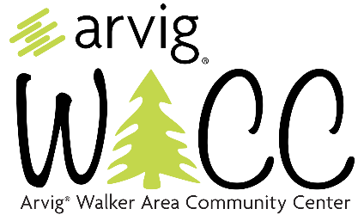
DAY PASS GUESTS PRICING
Pickleball Day Pass $10
Punch Card of 12 Passes $100
Pickleball Day Pass + Fitness Center $15
Punch Card of 12 Passes $150

MEMBERS PRICING
Pickleball $5
Silver Sneakers/Supplemental Insurance
Paid Fitness Center Members
Punch Card of 12 Passes $50

Pickleball $0
Regular Paid Memberships that ONLY utilize for Pickleball

